**Student Name: Shinde Smita Shahaji**

**UID: 20BCS4643**

**Date of Performance: 30/04/2021**

**Branch: CSE_IOT Section/Group: IOT_B**

**Subject Name-Digital electronics**

**Aim**

**Design a LED Chaser Circuit using Johnson Decade Counter (CD 4017) and Push button**.

**Task to be done**

*(Objective of the task to be explained)*

CD4017 IC, Push button and using concept Johnson decade counter designing the LED chaser which after implementation led glowing in sequence when we start simulation and when push button is triggered led stop at that led .

**Requirements**

*(Hardware and software requirements)*

# Software –

Tinker cad.

# Hardware –

|  |  |  |
| --- | --- | --- |
| sr.no | Apparatus | Quantity |
| 1. | CD4017 IC | 1 |
| 2. | Push button | 1 |
| 3. | 5V Power Supply | 1 |
| 4. | Connecting wires | As per requirement |
| 5. | Led | 8 |
| 6. | Breadboard | 1 |
| 7. | 1kohm resistance | 1 |
| 8. | Arduino-uno | 1 |

**Circuit diagram/ Block diagram**

*(Insert circuit diagram here)*

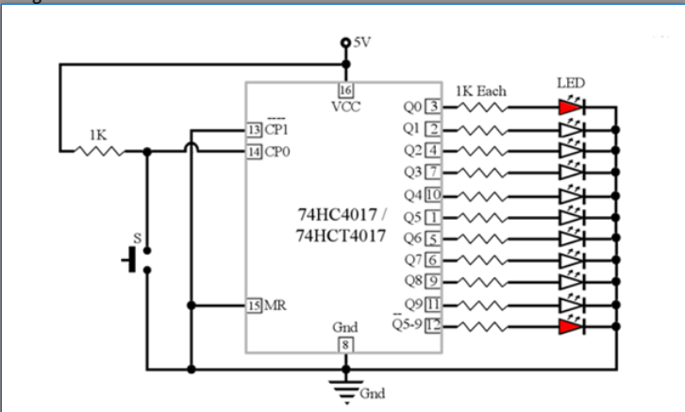

Circuit diagram on thinker cad

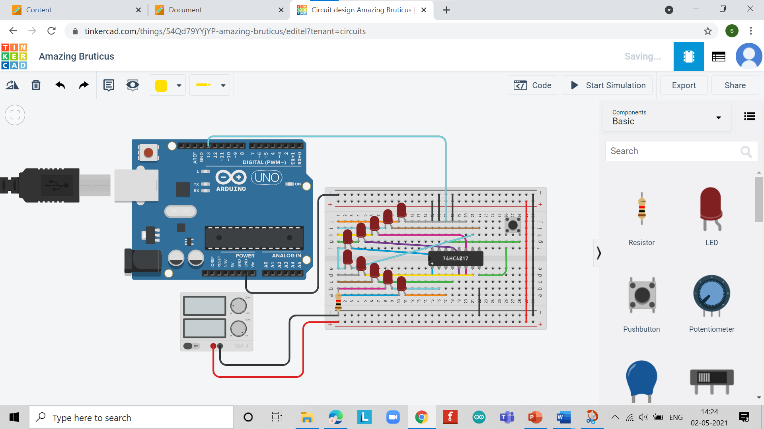

**Simulation Results:**

*(Insert simulation results )*

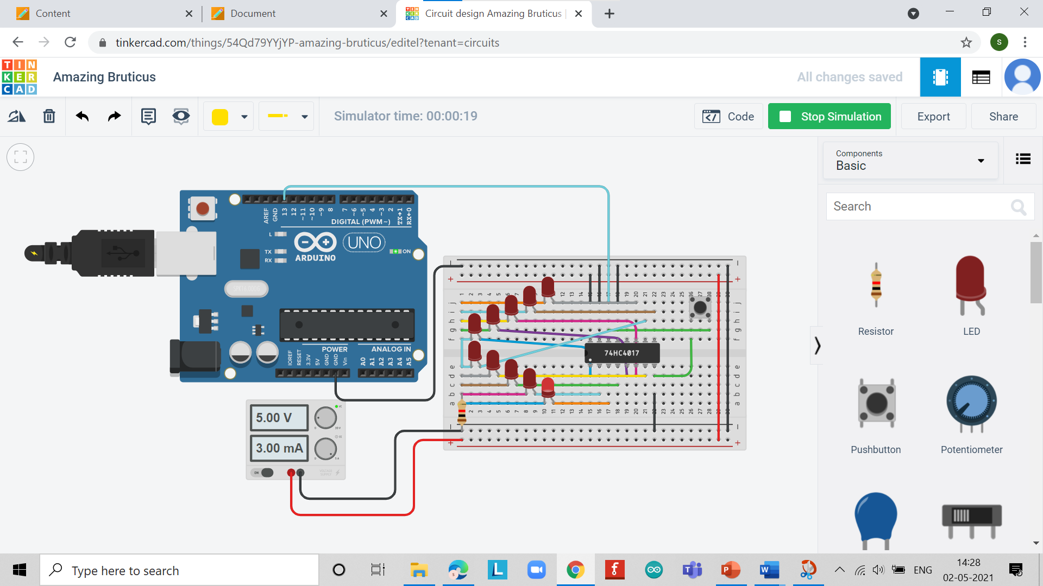

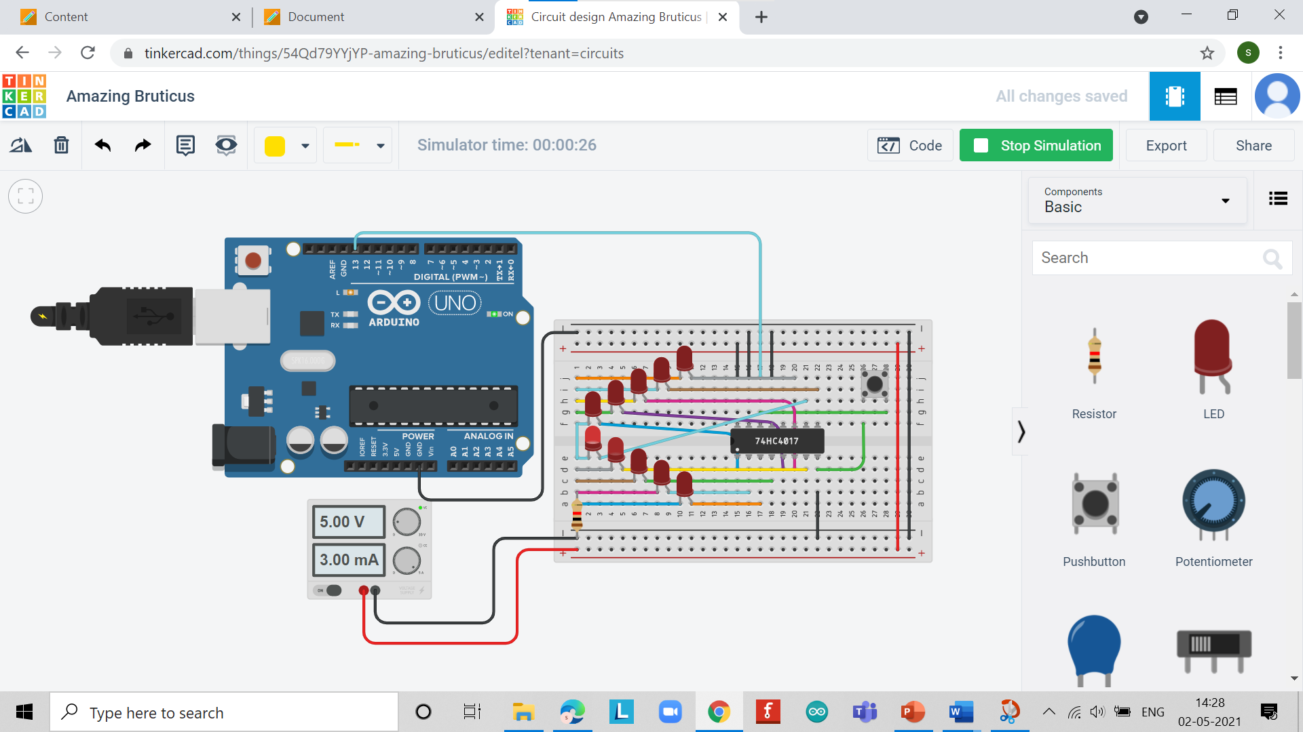

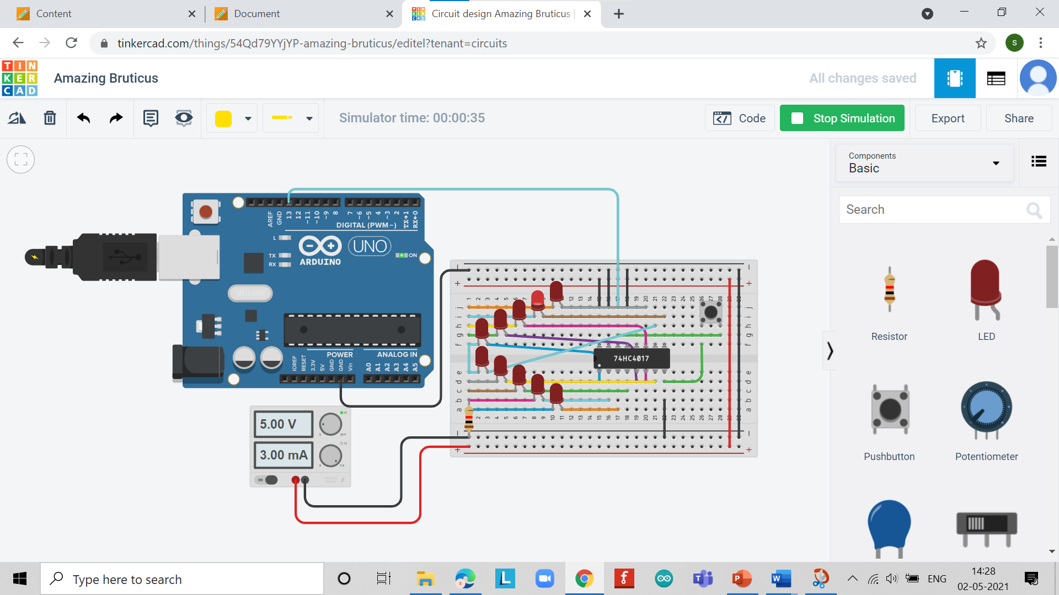

**Concept used**

*(Point out the concepts used in order to design the solution)*

* It is actually a clocked decade counter/divider IC with 10 fully decoded short-circuit-proof outputs that can each be used to directly drive a simple LED display.
* If desired, various outputs can be coupled back to the IC control terminals to make the device count to (or divide by) any number from two to nine and then either stop or re-start another counting cycle.
* Numbers of 4017B ICs can be cascaded to give either multi-decade division or to make counters with any desired number of decoded outputs.
* The 4017B is thus an exceptionally versatile device that can easily be used to chase or sequence a basic LED display of virtually any desired length.
* A toggle switch can use to ON and OFF the LED’S alternatively with the incoming pulses. The circuit uses a decade counter IC 4017, which counts each positive edge triggering pulse (here we provide by push switch).

**Learning/ observation**

*(Observations made during the experiment and learnings for future reference)*

* chaser or sequencer is one of the most popular types of LED-driving circuit and is widely used in advertising displays and in running-light ‘rope’ displays in small discos.
* Analyse the elements of digital system abstractions such as digital representations of information, digital logic and Boolean algebra.
* Design digital systems based on concepts that enable autonomous behaviour.
* Work in a team that can propose, design, implement and report on digital systems’ project.

**Troubleshooting**

*(Problems encountered and how did you solved those)*

Some problems occurred during the connections of led to Johnson decade counter because of this led is not glowing in sequential manner after I made reconnections properly that time it’s working properly

**Result**

The LED Chaser Circuit using Johnson Decade Counter and Push Button has been designed and Implemented.